Full Stack Development with MERN Project Documentation format

1. Introduction
- Project Title: ShopEZ: E-Commerce Application
- Team Members: Indivdual

2. Project Overview
- Purpose: ShopEZ is a full-stack e-commerce web application designed to allow users to browse products, manage a shopping cart, and place orders online. The goal of the project is to provide a simple, user-friendly, and scalable online shopping platform for customers and administrators.
. Features:
- Product listing and product details
- Store management
- Cart management
- Order placement
- Admin/seller product management
- MongoDB database integration
- REST API communication between frontend and backend

3. Architecture
- Frontend: The frontend is developed using React.js. It provides the user interface for customers and admins. React components are used to build pages such as home, products, cart, login, registration, and admin/store management pages. The frontend communicates with the backend using REST API calls.

- Backend: The backend is developed using Node.js and Express.js. It handles business logic, API routing, authentication, product operations, store operations, cart operations, and order management. Express routes are used to organize different modules of the application.

- Database: The application uses MongoDB as the database. MongoDB stores user details, product information, store details, cart items, and order records. The backend connects to MongoDB using a database configuration file such as server/config/db.js.

4. Setup Instructions
- Prerequisites: Node.js,npm,MongoDB or MongoDB Atlas,Git and Code editor such as VS Code
- Installation:
- Clone the project repository:
- Bash: git clone <repository-url>
- Open the project folder:
- Bash: cd e-commers
- Install frontend dependencies:
- Bash: cd client
- npm install
- Install backend dependencies:
- Bash: cd ../server
- npm install
- Create a .env file inside the server folder:
- Bash: PORT=5000
- MONGO_URI=<your-mongodb-connection-string>
- WT_SECRET=<your-secret-key>
- Start MongoDB locally or make sure MongoDB Atlas is connected

5. Folder Structure

e-commers/

│

├── client/

│ ├── public/

│ ├── src/

│ ├── index.html

│ ├── package.json

│ └── eslint.config.js

│

├── server/

│ ├── config/

│ │ └── db.js

│ ├── routes/

│ │ └── storeRoutes.js

│ ├── models/

│ ├── controllers/

│ ├── middleware/

│ ├── package.json

│ └── server.js

│

└── README.md
Client:
The client folder contains the React frontend application. It includes UI components, pages, styles, and frontend configuration files.
Server:
The server folder contains the Node.js and Express backend. It includes database configuration, API routes, controllers, models, and middleware.

6. Running the Application
• Provide commands to start the frontend and backend servers locally.
Frontend: _{npm run} dev (in the client directory)
Backend: _{npm run} dev (in the server directory)

7. API Documentation

Method | Endpoint | Description
POST | /api/users/register | Register a new user
POST | /api/users/login | Login user
GET | /api/products | Get all products
GET | /api/products/:id | Get product details
POST | /api/products | Add new product
PUT | /api/products/:id | Update product
DELETE | /api/products/:id | Delete product
GET | /api/stores | Get all stores
POST | /api/stores | Add new store
PUT | /api/stores/:id | Update store
DELETE | /api/stores/:id | Delete store
POST | /api/cart | Add item to cart
GET | /api/cart/:userId | Get user cart
POST | /api/orders | Place order
GET | /api/orders/:userId | Get user orders

Example Response:

{

"success": true,

"message": "Product fetched successfully",

"data": {

"name": "Smart Watch",

"price": 1999,

"category": "Electronics"

}

}

8. Authentication
Authentication is handled using email and password login. After successful login, the backend can generate a token such as a JWT token. This token is stored on the client side and sent with protected API requests.
Protected routes are used for admin/seller operations such as adding, updating, or deleting products and stores. Normal users can browse products, manage cart, and place orders.

- User Interface :-The user interface includes:
- Home page
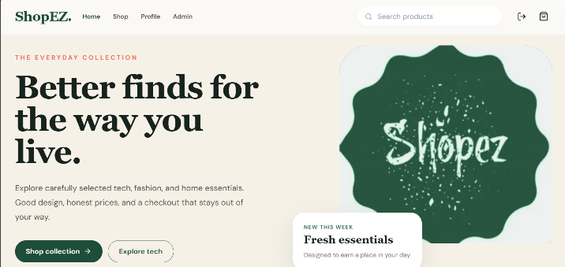
- Login page
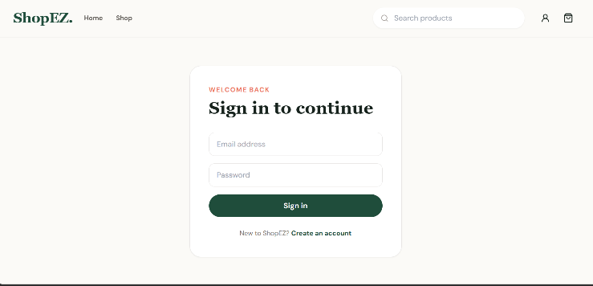

- Product listing page
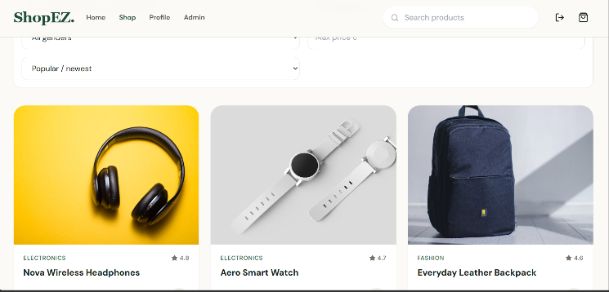

- Product details page
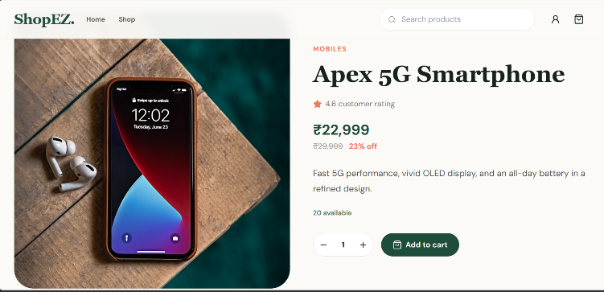

- Cart page
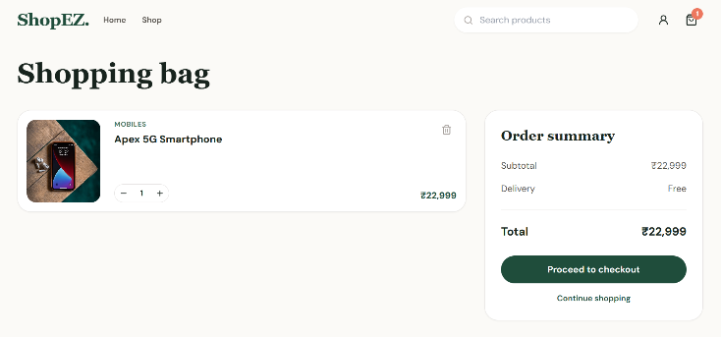
- Admin/seller management pages
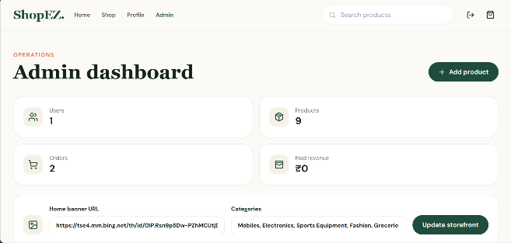
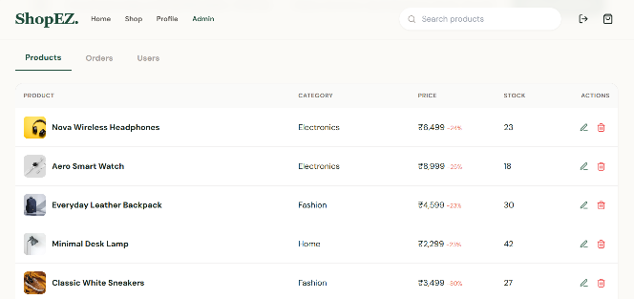

- Testing
Testing is done manually by checking the main workflows of the application.
Tested modules include:
- User registration
- User login
- Product display
- Store display
- Add to cart
- Remove from cart
- Place order
- Admin product management
- Database connection
- API responses
Tools used:
- Browser testing
- Postman for API testing
- Console/debug logs
- MongoDB database checking

- Screenshots or Demo
Add screenshots of the following pages:
- Home page
- Login page
- Product listing page
- Cart page
- Order confirmation page
- Admin/store management page
Demo link:
<add deployed application link here>

- Known Issues
Payment gateway is not implemented in the current version.
Email confirmation is not implemented.
Product image upload may depend on local or external image paths.
Advanced search and filtering may need improvement.
Order tracking is not available in the current version.

13. Future Enhancements
- Online payment gateway integration
- Email confirmation and order notifications
- Product reviews and ratings
- Wishlist functionality
- Advanced product search and filters
- Admin analytics dashboard
- Delivery tracking system
- Cloud image storage
- Mobile responsive improvements
- Deployment on cloud platforms like Vercel, Render, or Railway

